High Intensity PEMF vs Low Intensity PEMF

There seems to be debate over the effects of high intensity versus low intensity PEMF (Pulse Electro-Magnetic Field Therapy) and whether PEMF is even safe for people and animals. In gaining a deeper understanding of what PEMF does at the cellular level, you will find that there is no need for debate.

How does PEMF Work?
Each cell in your body has a magnetic field surrounding itself. This is the same magnetic field that doctors measure when they do an EKG or EEG. Cells function by pulling oxygen and nutrients in through the cell membrane to metabolize as energy and pushing waste and toxins out. This in and out process is what creates the magnetic field “charge” around each cell.
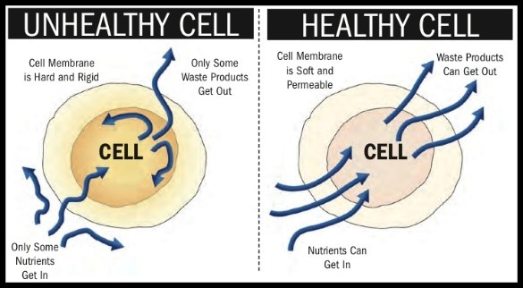
PEMF therapy uses a pulsing magnetic field to optimize cellular function. Science has proven that damaged, weak cells caused by stress, overuse, environmental toxins, poor nutrition, age, or injury have an imbalanced electrical charge (similar to that of a low battery). When the voltage of a cell is compromised, the cell membrane loses permeability, oxygen and nutrients cannot flow into the cell, and waste and toxins start accumulating inside the cell.

The body’s natural ability to rejuvenate itself slows down and physical dysfunction such as inflammation manifests.This is supported by Jerry Tenant, MD, MD(H), PSc. D in his book, Healing is Voltage. Dr. Tenant states in Chapter 3, "The cells of the body are designed to run at -20 to -25 millivolts. To heal by making new cells, we must achieve -50 millivolts. we get chronically sick (pain) when voltage drops below -20 millivolts. He also goes on to say "Thus chronic disease is always defined by low voltage."

Grapes or Raisins?
Think of a healthy cell as a fresh grape; round, soft and plump. Once a healthy cell or grape starts to lose its charge, it turns into a "raisin". The cell membrane becomes impermeable, cells start clumping together and inflammation sets in. Have you ever had a painful knot in your back? This is just a bunch of unhealthy cells that have clumped together.
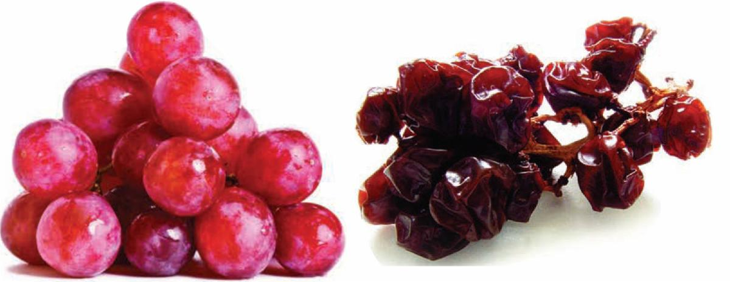

The pulsing magnetic field from a PEMF device turns on and then off many times a second in what is called the frequency. This magnetic field is attracted to unhealthy cells (the raisins, lacking in magnetic field) and goes right around the healthy cells (the grapes) because they have an established magnetic field around them. Consider holding two magnets. The positive end repels the other positive end. But when you hold the negative end out, the positive is attracted to it. Similarly, the pulsing magnetic field only interacts with the lower charged cells.

When the PEMF device pulses “on” the unhealthy cell expands, when it is “off” the cell relaxes. This action acts like “cellular exercise”. The stretching and relaxing opens the cell membranes and improves the cell’s permeability. This allows the cell to release pent-up waste and toxins (detox) and bring in fresh oxygen and nutrients. The in and out process resumes, recreating the energy or “charge” of the cell. And the newly charged cell no longer interacts with the magnetic field created by the PEMF device and instead repels it.

Is PEMF Safe?
With this new understanding of what PEMF does to the cells of living bodies, there is no longer a question of whether PEMF is safe. As previously mentioned, this has already been proven by thousands of double- blind studies done worldwide. Just check out some of the studies here: https://pemfinfo.com/index.php/studies-by-health-condition

and you can search in the US National Library of Medicine here: https://www.ncbi.nlm.nih.gov/pubmed/

PEMF simply recharges cells and stimulates a body’s natural ability to heal itself. And because you cannot overcharge a cell, the whole debate about high and low intensity becomes irrelevant. The real question is how do you deliver the right intensity to the right spot for the right amount of time to optimize cellular function...

So how do you get the right intensity to the right cells for the right amount of time?

When using a fully-adjustable PEMF system, ideally you would start out at a low intensity and turn up the intensity to a level that is comfortable to the horse or person. The sensation should feel similar to a deep tissue massage.
After treating thousands of horses and people with a high-intensity PEMF system.

I am still amazed at how the pulsing sensation shows up and is felt directly in the location related to the unwanted symptom(s). This is because the magnetic field is attracted to depleted cells in the body. With horses, you can visually experience this by the muscles twitching stronger in specific localized areas of their body, indicating discomfort or inflammation. I am also amazed at how quickly, people and animals respond and feel better, usually noticing a significant improvement in just one session.

A cell needs a certain amount of intensity to start its cellular exercise. Dr. Robert Dennis, one of the pioneers of PEMF and an original scientist for NASA, theorizes it takes between 25 and 85 Gauss to stimulate a cell to the level that starts to create cellular exercise and repair. This requires a much higher gauss capability than low intensity PEMF systems offer. ​

Although low intensity PEMF devices may offer some benefits over a very long duration of time, they are minimal when compared to the capabilities of a high intensity device. In addition to offering a gauss so low you cannot even feel a pulsing sensation, the delivery methods such as laying on a mat or using a probe are very limited. ​

We have tried and tested all kinds of PEMF systems... Because we really wanted to offer a lower price PEMF system, we have tried and tested many different manufacturers including Bemer and iMRS. In my own experimentation with using these systems, the results were so minimal and did not merit the expense or the time required to feel any positive effects, especially when results were so immediate and complete using the higher intensity systems.

When attempting to optimize the results of using PEMF, having adjustability in intensity and the delivery method becomes critical. When the cells have rejuvenated with an established magnetic field, the pulsing will diminish. It is then that the ability to adjust the intensity stronger becomes valuable. With a stronger magnetic field, you can reach deeper into the body through dense tissue to exercise new cells that need recharging, without sacrificing healthy cells on the surface like Laser and Shockwave.

Even with a higher intensity, as PEMF passes through a bone for example, it diminishes significantly. This can create a blank spot or shadow on the other side of the bone. When targeting specific organs or areas of the body that are in or around bones, it has been found to be far more effective to send two magnetic fields from opposing angles that join and surround the injured cells, than to push it from only one direction. Using accessories that allow you to surround tissue with PEMF from opposing sides with a strong intensity leads to noticeable and accelerated healing.

I hope this has given you a better understanding of what PEMF is and does. By understanding how the presence of a pulsing electro-magnetic field effects cellular function, and that you simply cannot overcharge a cell, it is safe to conclude that adjustable PEMF devices with capabilities of pulsing low to high intensity magnetic field strengths is tremendously beneficial to health and are safe to use. ​

PEMF System Recommendation...
After many years of exhaustive research, trying and testing many different PEMF devices, and treating thousands of horses, pets and people, we have determined that the PULSE Centers products and accessories are the only PEMF systems that offer the dual magnetic fields in a full line of human and equine accessories that can optimally surround the cells in a pulsing magnetic field.
The three different PULSE Centers models offer more than enough intensity to power all the different accessories and are fully adjustable to provide the right intensity and frequency combination for people or horses and pets. Because of this superiority in performance, we have chosen to only use the PULSE Centers Equine PEMF Systems in our Therapy business and offer them to our clients.
If you would like more information on PEMF, the PULSE Centers products and accessories and how they can benefit you and your horses, call me personally at (828) 243-1110 or visit our website: horsepemf.com

